**Programming the PST:**

Items Needed

* Microchip USB HID Bootloader v2.6
* Hyper Terminal
* PST Hex File
* USB Cable
* PST

Instructions

Note: In order t load the PST firmware the PST Bootloader needs to be installed.

* Plug the USB cable into the back of the PST and connect to the computer.
* Find the serial port that was added when the PST was plugged in
* Connect to this COM port via Hyper Terminal, set the baud rate to 9600 and hardware flow to none
* Type $v and verify that we are connected to the PST
* If you are connected to the PST, type BL. This will place the PST into bootloader. Close HyperTerminal
* Open Microchip USB HID Bootloader v2.6. The “Open Hex File” should be enabled. Click this button.
* Navigate to the PST hex file.
* Click “Program/Verify”
* 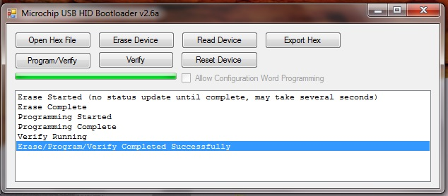A successful program – refer to figure 1

Figure – Successful

Trouble Shooting

If the Open Hex file is not available, the PST did not switch into Bootloader mode. Connect a resistor from pin RE7 to GND (Cliff has this picture). Older revision boards did not have the proper pull down resistor.